Judul : Koneksi Database

Nama Kelompok : Salamah Nur Aqidah

Citra Puspita Pebriani

Lestari

Ema Karima Nur’azizah

Afifah Nafis

Program : Tech Muda Batch 4

1. Tampilan Web – Tiketku

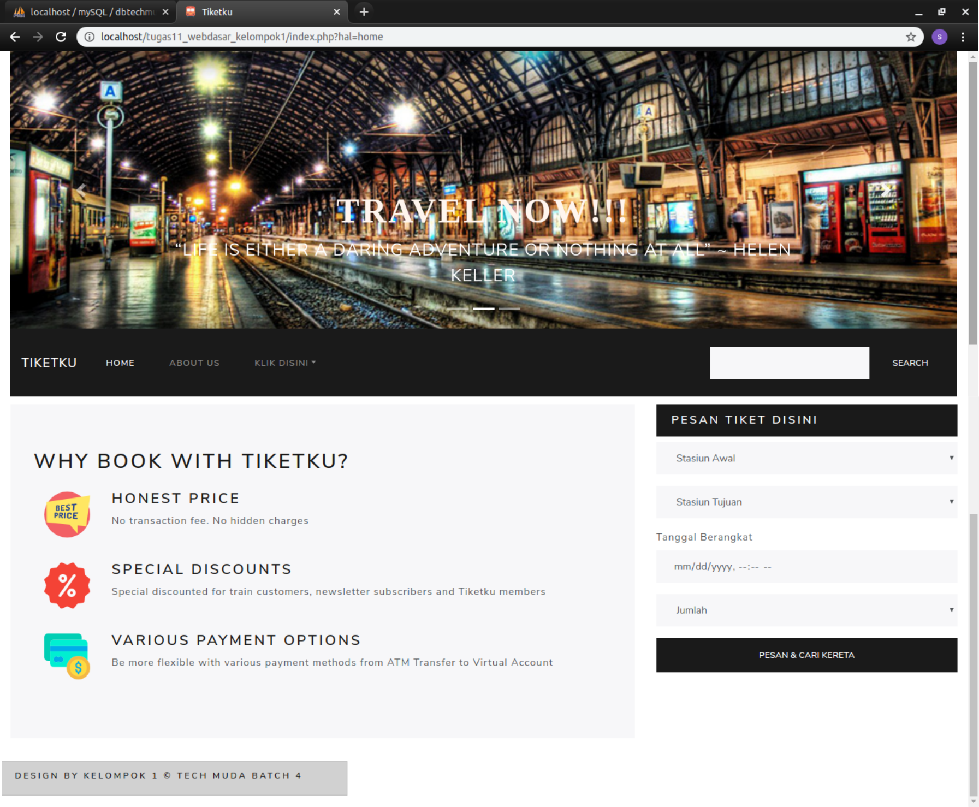

|  |
| --- |
| Index.php |
| <?php  include_once 'koneksi.php';  include_once 'models/Pegawai.php';  include_once 'header.php';  include_once 'menu.php';  echo '<br/>';  include_once 'main.php';  include_once 'sidebar.php';  echo '<br/>';  include_once 'footer.php' |

1. Tampilan Menu – About Us

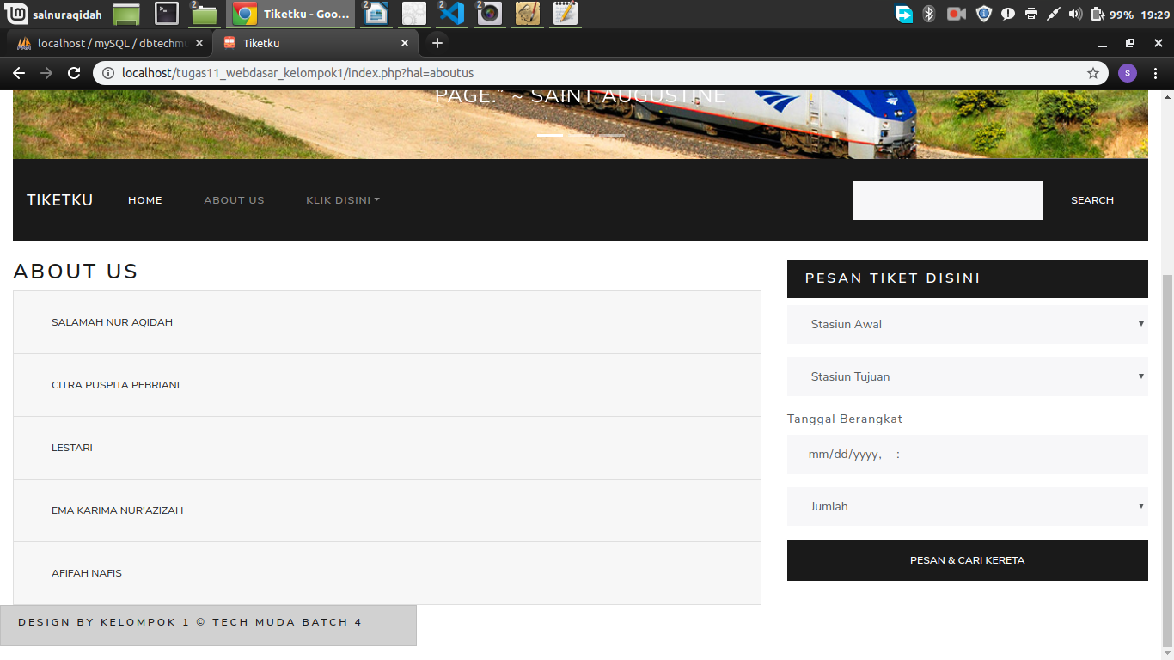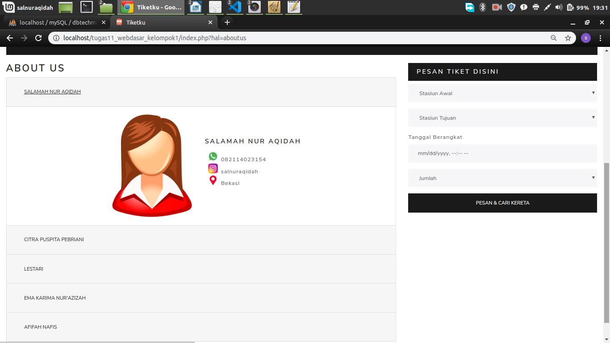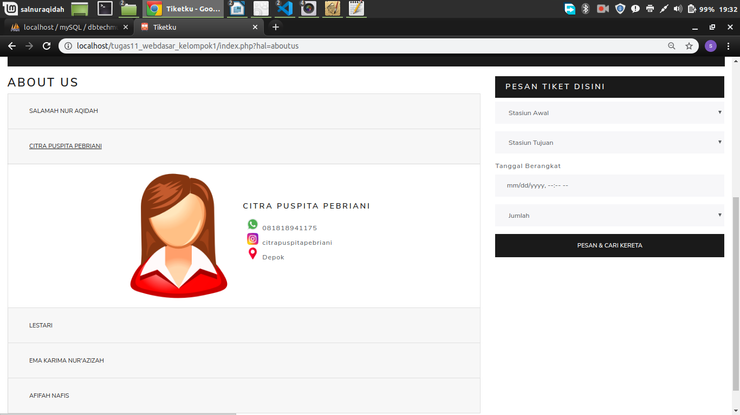

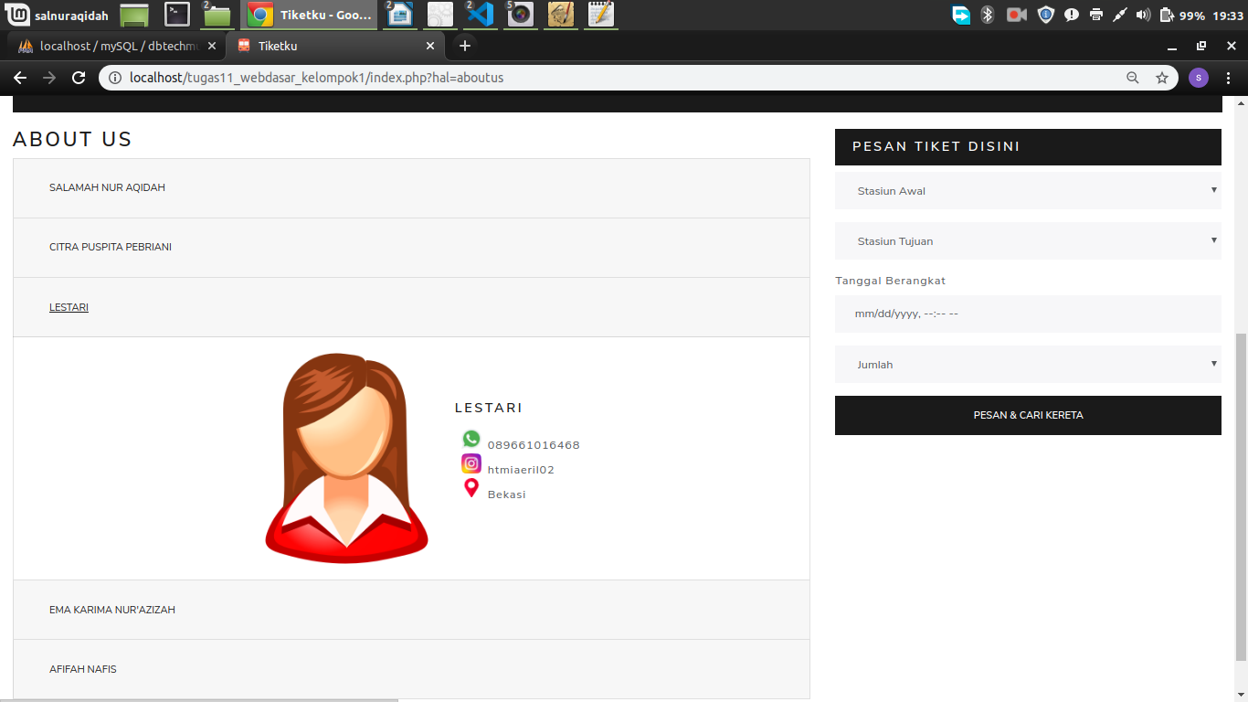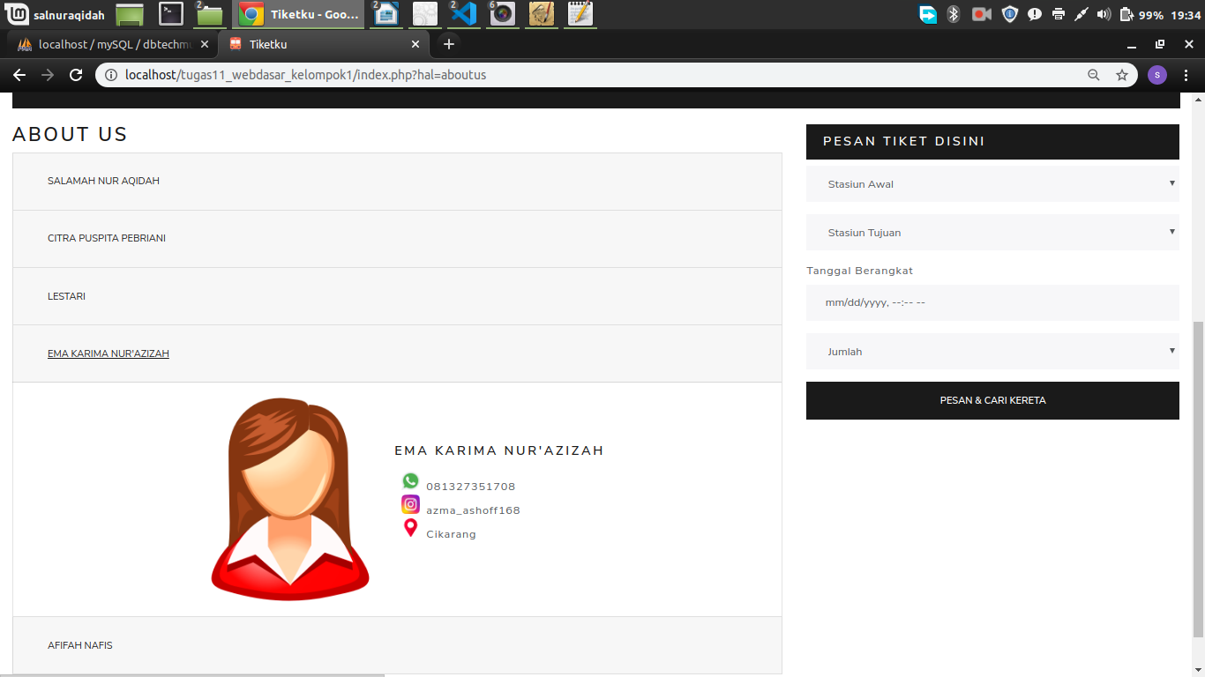

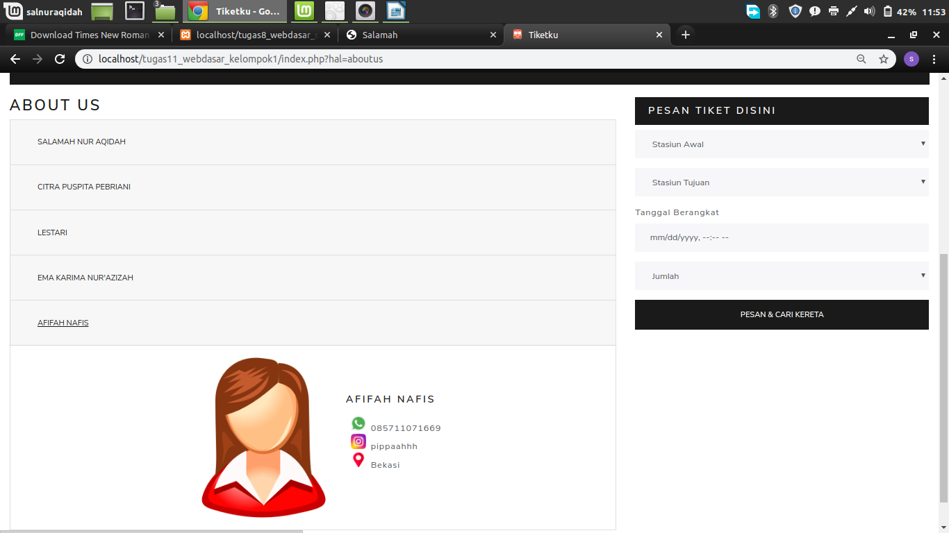

1. Koneksi database – Tabel Customer

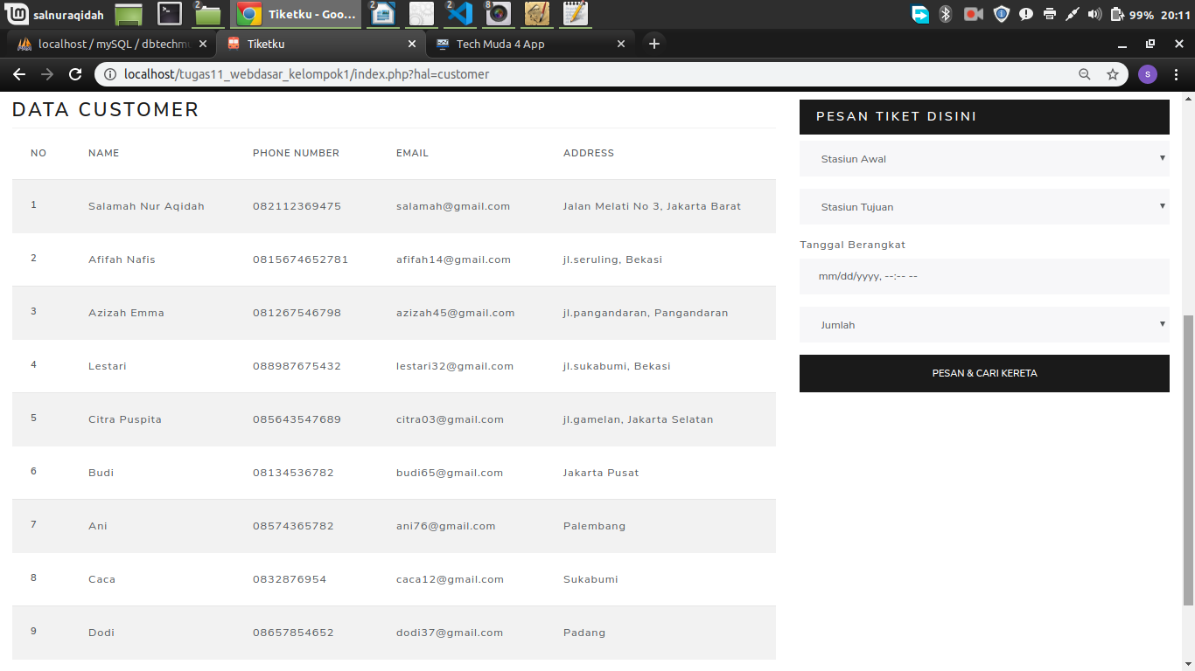

|  |
| --- |
| koneksi.php |
| <?php  /* Connect to a MySQL database using driver invocation */  $dsn = 'mysql:dbname=dbtiketkereta;host=localhost';  $user = 'root';  $password = '';  try {  $dbh = new PDO($dsn, $user, $password);  $dbh->setAttribute(PDO::ATTR_ERRMODE, PDO::ERRMODE_EXCEPTION);  $dbh->setAttribute(PDO::MYSQL_ATTR_USE_BUFFERED_QUERY,TRUE);  } catch (PDOException $e) {  echo 'Connection failed: ' . $e->getMessage();  }  ?> |

|  |
| --- |
| Customer.php |
| <?php  class Customer{  //member1 var  private $koneksi;  //member2 constructor  public function __construct(){  global $dbh; //panggil var instance pdo  $this->koneksi = $dbh;  }  //member3 fungsi2 crud  public function dataCustomer(){  $sql = "select * from customer";  //prepare statement PDO  $ps = $this->koneksi->prepare($sql); //persiapan  $ps->execute(); //eksekusi  $rs = $ps->fetchAll(); // ambil seluruh baris data  return $rs;  }  };  ?> |

1. Koneksi database – Tabel Order

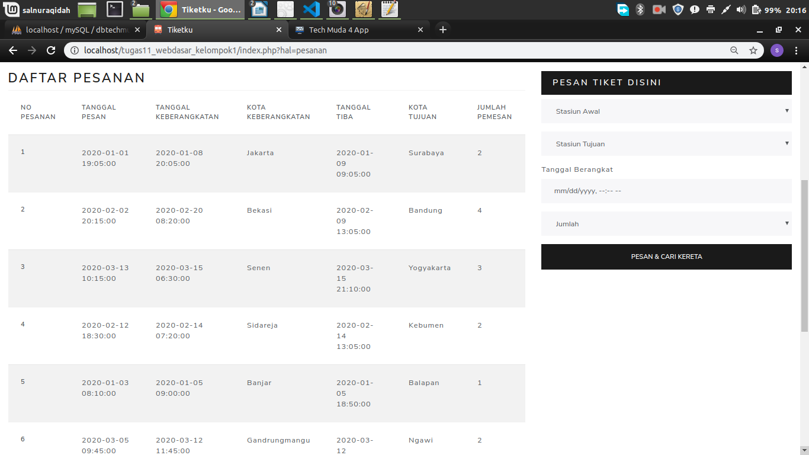

|  |
| --- |
| Pesanan.php |
| <?php  class Pesanan{  //member1 var  private $koneksi;  //member2 constructor  public function __construct(){  global $dbh; //panggil var instance pdo  $this->koneksi = $dbh;  }  //member3 fungsi2 crud  public function dataPesanan(){  $sql = "select * from pesanan";  //prepare statement PDO  $ps = $this->koneksi->prepare($sql); //persiapan  $ps->execute(); //eksekusi  $rs = $ps->fetchAll(); // ambil seluruh baris data  return $rs;  }};?> |

1. Koneksi database – Tabel Payment

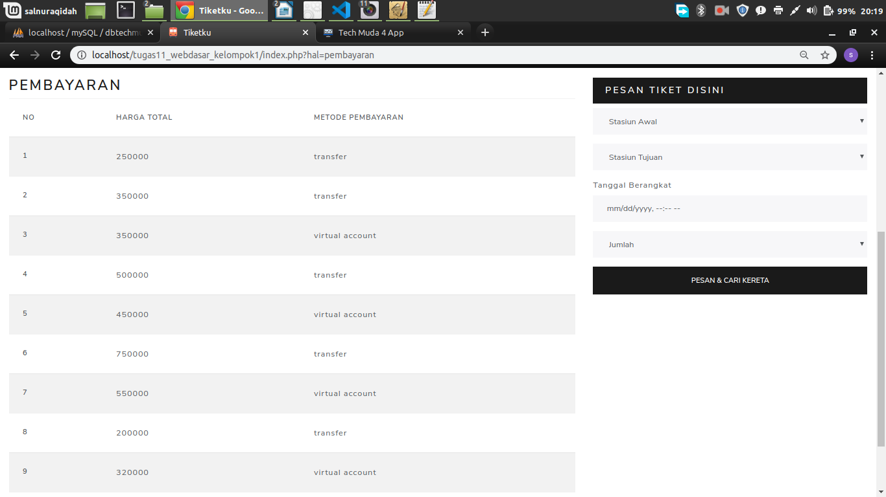

|  |
| --- |
| Pembayaran.php |
| <?php  class Pembayaran{  //member1 var  private $koneksi;  //member2 constructor  public function __construct(){  global $dbh; //panggil var instance pdo  $this->koneksi = $dbh;  }  //member3 fungsi2 crud  public function dataPembayaran(){  $sql = "select * from pembayaran";  //prepare statement PDO  $ps = $this->koneksi->prepare($sql); //persiapan  $ps->execute(); //eksekusi  $rs = $ps->fetchAll(); // ambil seluruh baris data  return $rs;}};?> |